Take a Mindful Moment via YouTube

Help UVA Go Green!
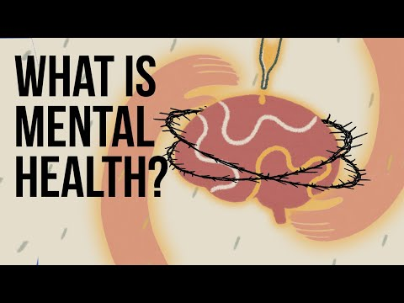
UVA has a commitment to sustainability which includes recycling, composting, and eliminating single-use plastics. Refer to their website to see how you can help UVA reduce harmful environmental effects.
We also ask that you use appropriately labeled bins for anything you discard at Zehmer Hall or elsewhere on Grounds.

Note this Week’s Announcements
- Pre-Entrance Health Form: Please make arrangements to complete any remaining health requirements. It is mandatory to satisfy all health requirements by August 1st.
- UVA Health & Cville Free Clinic Orientations will be on Tuesday, June 28th starting at 2:30pm.
- Monday, July 4th: No classes will be held.
- Save the Dates: We’ll be hosting some afternoon sessions on July 6th, July 25th, and August 3rd.
- Student Council Nominations! Refer to Student Handbook for a list of job descriptions- nominate yourself or others for specific roles by emailing postbac@virginia.edu. We’ll compile nominees for a voting ballot.
- COVID Precautions: Although there isn’t a University mask mandate, wearing PPE when in class/review sessions may help limit transmission. See previous email with message from Chem Dept Chair, Professor Venton for more info.

Journal on a Reflection Question
(taken directly from medical school secondary applications)

What does a collaborative learning environment mean to you?

