Your "Experiences" section of your future medical school application is the first thing you will work on as a PBPM student, but may be the section that an Admissions Committee spends the most amount of time reviewing. Don't worry- you can meet with an advisor as many times as you want until you feel ready to hit "submit"!
For this section, you will have the opportunity to list up to 15 experiences in the following categories:
- Artistic endeavors
- Employment
- Teaching/Tutoring/Teaching Assistant
- Military service
- Community service: non-medical
- Community service: medical
- Shadowing
- Awards/Honors
- Extracurricular
- Research/Publications
- Presentation/Posters
- Leadership
- Hobbies
- Conferences
<< Not AMCAS categories, but helpful to note with your advisor.
- Entrepreneurial/Business Ventures
- Cultural Explorations/Study Abroad
Each "Experience Description" is limited to 700 characters including spaces. Note: a lot of identifying information will be listed before you even start writing the Experience Description, so don't waste space by duplicating information!
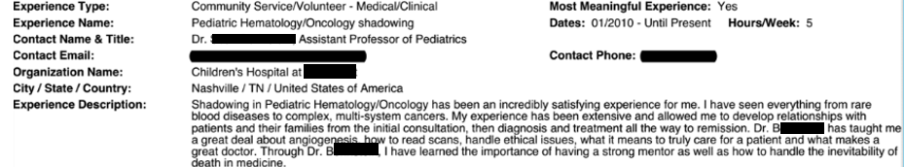
Experience Type: Most Meaningful: Yes/No
Experience Name: Dates: Hours/Week:
Contact Name & Title:
Cotact Email: Contact Phone:
Organization Name:
City/State/Country:
Experience Description (700 characters w/spaces):

Experience Type: Most Meaningful: Yes/No
Experience Name: Dates: Hours/Week:
Contact Name & Title:
Cotact Email: Contact Phone:
Organization Name:
City/State/Country:
Experience Description (700 characters w/spaces):

Experience Type: Most Meaningful: Yes/No
Experience Name: Dates: Hours/Week:
Contact Name & Title:
Cotact Email: Contact Phone:
Organization Name:
City/State/Country:
Experience Description (700 characters w/spaces):

Experience Type: Most Meaningful: Yes/No
Experience Name: Dates: Hours/Week:
Contact Name & Title:
Cotact Email: Contact Phone:
Organization Name:
City/State/Country:
Experience Description (700 characters w/spaces):

Experience Type: Most Meaningful: Yes/No
Experience Name: Dates: Hours/Week:
Contact Name & Title:
Cotact Email: Contact Phone:
Organization Name:
City/State/Country:
Experience Description (700 characters w/spaces):

Experience Type: Most Meaningful: Yes/No
Experience Name: Dates: Hours/Week:
Contact Name & Title:
Cotact Email: Contact Phone:
Organization Name:
City/State/Country:
Experience Description (700 characters w/spaces):

Experience Type: Most Meaningful: Yes/No
Experience Name: Dates: Hours/Week:
Contact Name & Title:
Cotact Email: Contact Phone:
Organization Name:
City/State/Country:
Experience Description (700 characters w/spaces):

Experience Type: Most Meaningful: Yes/No
Experience Name: Dates: Hours/Week:
Contact Name & Title:
Cotact Email: Contact Phone:
Organization Name:
City/State/Country:
Experience Description (700 characters w/spaces):

Experience Type: Most Meaningful: Yes/No
Experience Name: Dates: Hours/Week:
Contact Name & Title:
Cotact Email: Contact Phone:
Organization Name:
City/State/Country:
Experience Description (700 characters w/spaces):

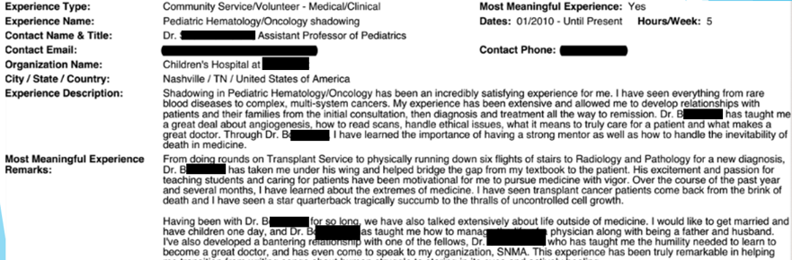
For 3 of your 15 Experiences, you are able to annotate them as "Most Meaningful Experience". Keep in mind - you still have a basic "Experience Description" with 700 characters (including spaces!), but you also have an additional 1325 characters (including spaces) to write why it was so meaningful to you.
Experience Type: Most Meaningful: Yes/No
Experience Name: Dates: Hours/Week:
Contact Name & Title:
Cotact Email: Contact Phone:
Organization Name:
City/State/Country:
Experience Description (700 characters w/spaces):

Experience Type: Most Meaningful: Yes/No
Experience Name: Dates: Hours/Week:
Contact Name & Title:
Cotact Email: Contact Phone:
Organization Name:
City/State/Country:
Experience Description (700 characters w/spaces):

Experience Type: Most Meaningful: Yes/No
Experience Name: Dates: Hours/Week:
Contact Name & Title:
Cotact Email: Contact Phone:
Organization Name:
City/State/Country:
Experience Description (700 characters w/spaces):

Experience Type: Most Meaningful: Yes/No
Experience Name: Dates: Hours/Week:
Contact Name & Title:
Cotact Email: Contact Phone:
Organization Name:
City/State/Country:
Experience Description (700 characters w/spaces):

Most Meaningful Experience Remarks (1325 characters w/spaces):

Experience Type: Most Meaningful: Yes/No
Experience Name: Dates: Hours/Week:
Contact Name & Title:
Cotact Email: Contact Phone:
Organization Name:
City/State/Country:
Experience Description (700 characters w/spaces):

Most Meaningful Experience Remarks (1325 characters w/spaces):

Experience Type: Most Meaningful: Yes/No
Experience Name: Dates: Hours/Week:
Contact Name & Title:
Cotact Email: Contact Phone:
Organization Name:
City/State/Country:
Experience Description (700 characters w/spaces):

Most Meaningful Experience Remarks (1325 characters w/spaces):

